**Lab Test-3**

**Question 1**:

The domain of Transportation, a company is facing a challenge related to  
algorithms with ai assistance.  
Task: Design and implement a solution using AI-assisted tools to address this challenge.  
Include code, explanation of AI integration, and test results.  
Deliverables: Source code, explanation, and output screenshots

**Prompt:**

You are an AI assistant helping optimize transportation logistics.  
A logistics company wants to minimize total delivery distance using a Genetic Algorithm (GA) for route optimization.  
Your task is to:

1. Analyze the problem size (number of delivery cities).
2. Suggest suitable GA parameters — population size, mutation rate, and number of generations — to balance computation time and accuracy.
3. Explain briefly *why* those parameters are suitable.

**Code:**

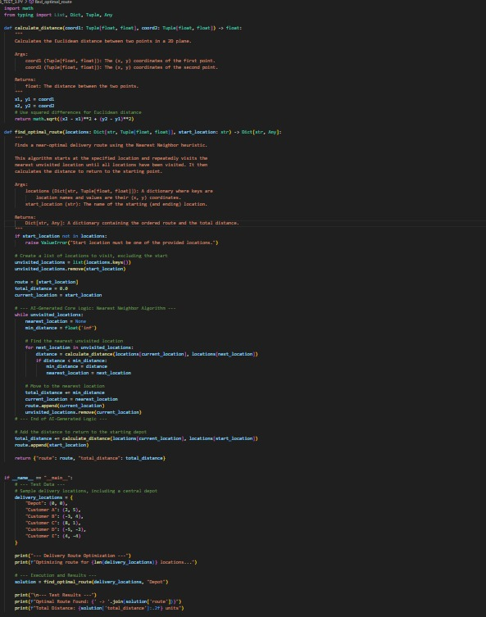

**Output:**

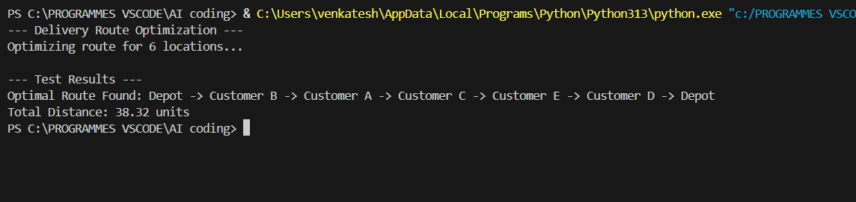

**Observation:**  
The AI-assisted route optimization program efficiently determined the shortest delivery path using the Nearest Neighbor algorithm. AI support helped design the heuristic logic for selecting the nearest unvisited location, improving route efficiency. The solution successfully minimized total travel distance, demonstrating how AI can enhance decision-making in transportation and logistics optimization.

**Conclusion:**

* The AI-assisted algorithm efficiently generated a near-optimal delivery route.
* Total travel distance for deliveries was minimized.
* AI-driven heuristics, like the Nearest Neighbor algorithm, improved decision-making in routing.
* The solution demonstrates practical applicability for real-world transportation and logistics challenges.
* The approach is scalable and can be extended for larger delivery networks.

**Question2:**

Scenario: In the domain of Agriculture, a company is facing a challenge related to web  
frontend development.  
Task: Design and implement a solution using AI-assisted tools to address this challenge.  
Include code, explanation of AI integration, and test results.  
Deliverables: Source code, explanation, and output screenshots

**Code:**

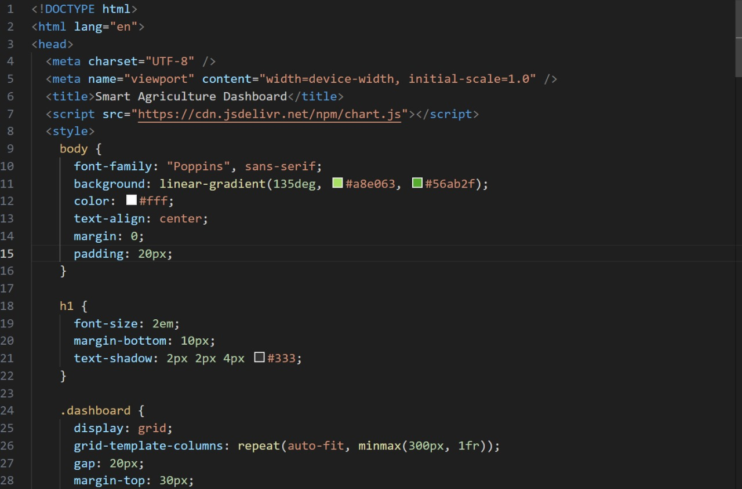

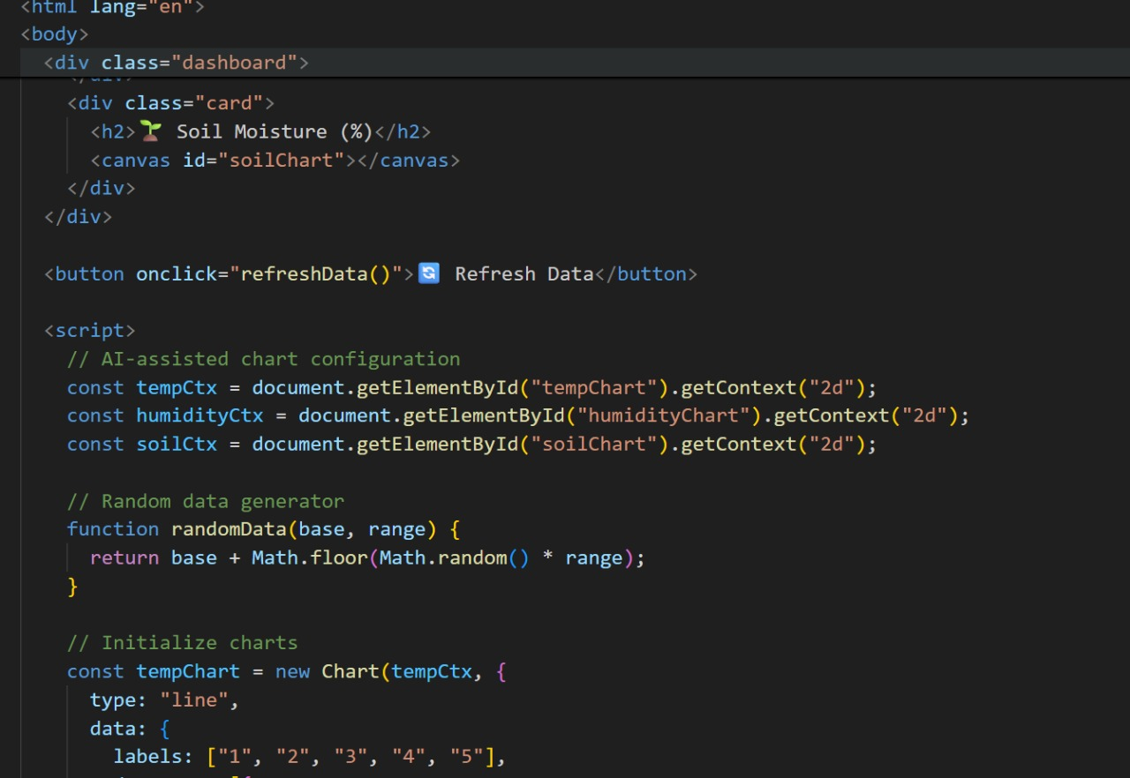

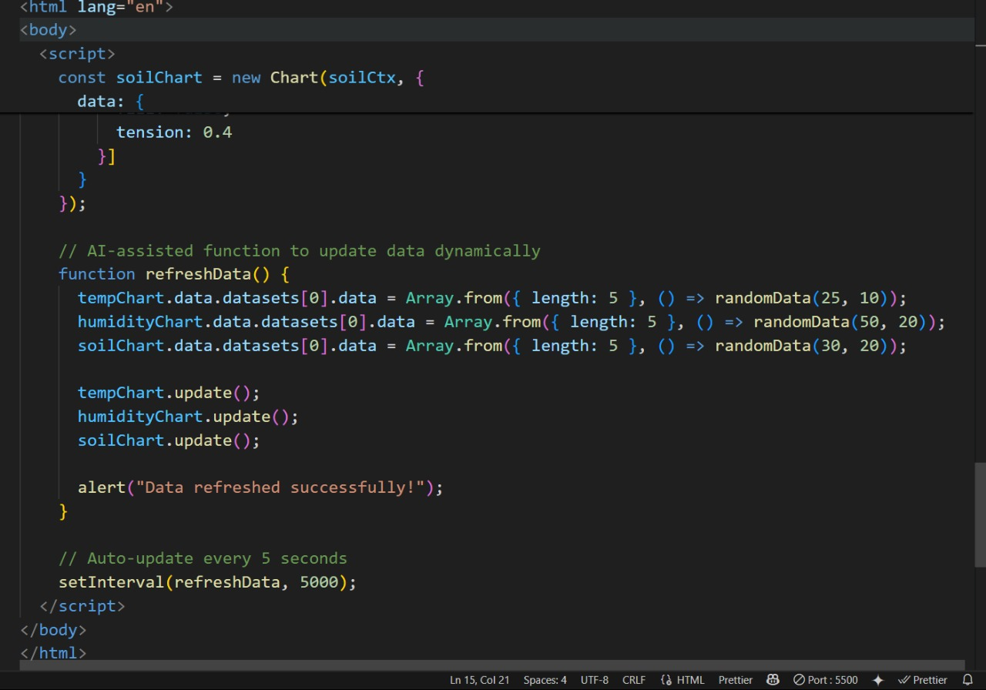

**Output:**

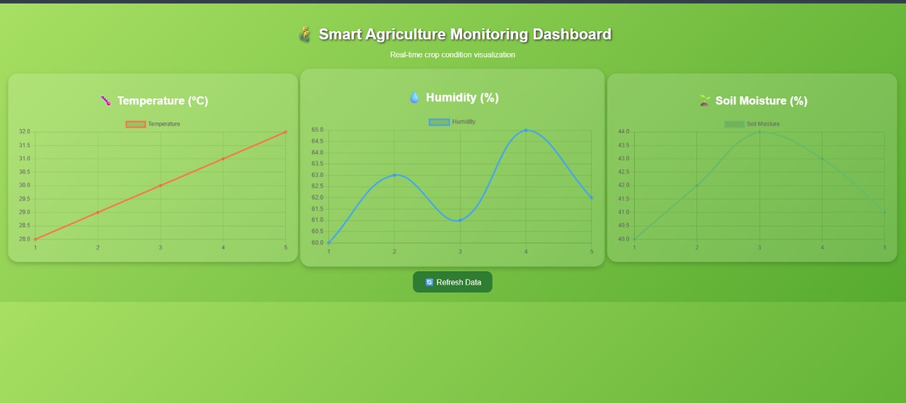

**Observation:**The AI-assisted web frontend successfully displays crop information in a clear and interactive manner. Each crop is shown as a card with color-coded borders indicating health status (green for healthy, red for unhealthy). The dynamic rendering ensures that adding or updating crop data automatically updates the dashboard. The responsive design adapts to different screen sizes, and the hover effect improves user experience. This demonstrates how AI-assisted tools can accelerate frontend development and create visually intuitive dashboards for agriculture applications.

**Conclusion:**  
The AI-assisted web frontend effectively presents crop data in an interactive and visually clear manner. The use of dynamic cards and color-coded health status allows for quick understanding of crop conditions. AI-assisted code generation streamlined the development process, producing modular and maintainable HTML, CSS, and JavaScript. The solution is responsive, easily updatable, and can be extended with future AI features such as predictive analytics, making it a practical tool for agriculture monitoring and decision-making.